**Tab 3- Activities**

**Excursions**

All activities and excursions are carefully planned and follow our expert health and safety check analysis. Lee Valley’s excellent location, allows us to take full advantage of easy and comfortable access to London by train. For any other excursions outside of London or the Lee Valley vicinity a high quality coach service is provided. Packed lunches are provided on all excursions.

AIE organise students into smaller leader accompanied groups for each excursion. Students follow our staff wearing AIE uniforms. Our desire to connect the classroom with our activities program also means that our teachers are also involved with excursions either by pre-teaching material associated with the visits or by joining and guiding the students on the visit with the activity leaders on a rota basis. Full health and safety risk assessments are expertly carried out for each and every part of the camp’s duration.

Our final activities and excursions program with include a selection of the following:

**London Musical**

**Walking Tour to visit Big Ben, Houses of Parliament, London Bridge Buckingham Palace**

**Ride on the London Eye**

**Thames river boat disco**

**Daytrip to Cambridge or Oxford**

**Daytrip to the beach**

**Daytrip to Windsor Castle**

**Stadium Visit to Football ground or Olympic stadium bus tour (03002012001)**

**The British Museum or Natural History Museum**

**Madame Tussaud’s**

**The Tower of London**

**The London Aquarium**

**The on-site activities**

The on-site activities are not only designed for the students to use their English skills on a daily basis with other members of the group, but they also allow the students to build in confidence, enjoy being part of a team, encourage creativity, organisation and personal expression.

**Lee Valley:** White Water Rafting, horse-riding, ice skating, swimming, canoeing, golf, cycling, tennis, badminton, basketball, volleyball

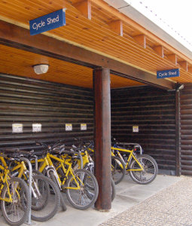 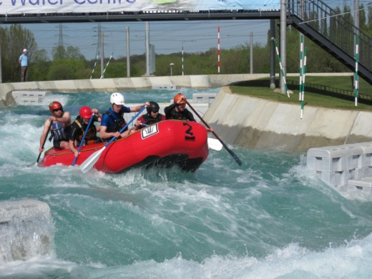 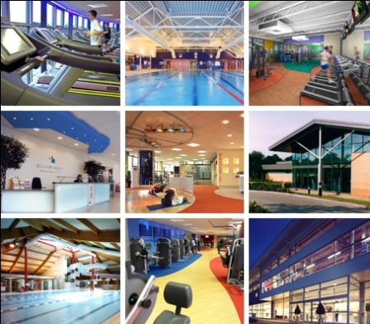

**Onsite activities:** Mini Olympics, Fashion show, Murder Mystery, Miss World and Mr. Muscle contest, AIE’S Got Talent variety show, Football, Orienteering, Cinema night, Karaoke, Quiz Challenge, Street Dance workshop, Drama workshop, Treasure hunt, Table tennis, Dodge ball, Volleyball